Client Intake Form- Therapeutic Massage
Personal Information
Name: ______________________________________________ Date: ___________ Phone: ___________________
Address: ______________________________________________________________________________________
City/State/Zip: _________________________________________________________________________________
Email: _____________________________________ Date of Birth: ___________Occupation: _________________
Emergency Contact: ____________________________________________Phone: __________________________

The following information will be used to help plan safe and effective massage sessions. Please answer the questions to the best of your knowledge.

Date of Initial Visit__________________________________

- Have you had a professional massage before? Yes No
If yes, how often do you receive massage therapy? _____________________________________

- Do you have any difficulty lying on your front, back or side? Yes No
If yes, please explain ____________________________________________________________

- Do you have any allergies to oils, lotions, or ointments? Yes No
If yes, please explain ____________________________________________________________

- Do you have sensitive skin? Yes No
- Are you wearing contact lenses ( ), dentures ( ), a hearing aid ( )?
- Do you sit for a long hours at a workstation, computer, or driving? Yes No
If yes, please describe ___________________________________________________________

- Do you perform any repetitive movement in your work, sports, or hobby? Yes No
If yes, please describe ___________________________________________________________

- Do you experience stress in your work, family, or other aspect of your life? Yes No
If yes, how do you think it has affected your health? _________________________________________
Muscle tension ( ), anxiety ( ), insomnia ( ), irritability ( ), other ________________________________

- Is there a particular area of the body where are experiencing tension, stiffness, pain, or
other discomfort? Yes No
If yes, please identify ____________________________________________________________

- Do you have any particular goals in mind for this massage session? Yes No
If yes, please explain ____________________________________________________________

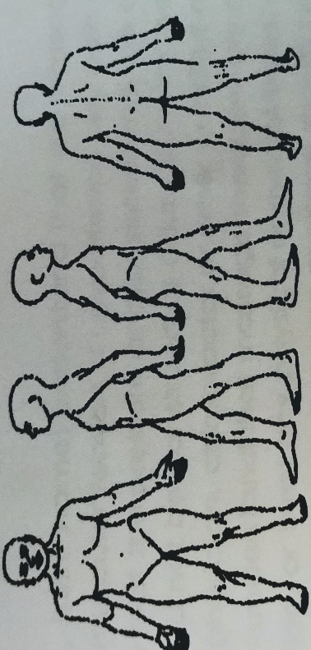
Continued on page 2
Circle any specific areas you would like the massage therapist to concentrate on during the session:
Medical History

In order to plan a massage session that is safe and effective, we need some general information about your medical history.

- Are you currently under medical supervision? Yes No
If yes, please explain ______________________________________________________________

- Do you see a chiropractor? Yes No If yes, how often? _________________________________
- Are you currently taking any medication? Yes No
If yes, please list _______________________________________________________________________________
- Are you on any blood thinners? Yes No

- Have you suffered from stroke before? Yes No

- Please check any condition listed below that applies to you:
( ) contagious skin condition ( ) phlebitis
( ) open sores or wounds ( ) deep vein thrombosis/blood clots
( ) easy bruising ( ) joint disorder/rheumatoid arthritis/osteoarthritis/tendonitis
( ) recent accident or injury ( ) osteoporosis
( ) recent fracture ( ) epilepsy
( ) recent surgery ( ) headaches/migraines
( ) artificial joint ( ) cancer
( ) strains/sprains ( ) diabetes
( ) current fever ( ) decreased sensation
( ) swollen glands ( ) back/neck problems
( ) allergies/sensitivity ( ) Fibromyalgia
( ) heart condition ( ) TMJ
( ) high or low blood pressure ( ) carpal tunnel syndrome
( ) circulatory disorder ( ) tennis elbow
( ) varicose veins ( ) pregnancy If yes, how many months? ___________________
( ) atherosclerosis ( ) stroke

Please explain any condition that you have marked above _____________________________________________________________
________________________________________________________________________________________________________________________________________________________________________________________________________________________

- Is there anything else about your health history that you think would be useful for your massage practitioner to know to plan a safe and effective massage session for you? ________________________________________________________________
____________________________________________________________________________________________________

Draping will be used during the session- only the area being worked on will be uncovered. Clients under the age of 17 must be accompanied by a parent or legal guardian during the entire session. Informed written consent must be provided by the parent or legal guardian for any client under the age of 17.

I, _____________________________________ (print name) understand that the massage I receive is provided for the basic purpose of relaxation and relief of muscular tension. If I experience any pain or discomfort during this session, I will immediately inform the therapist so that the pressure and/or strokes may be adjusted to my level of comfort. I further understand that massage should not be construed as a substitute for medical examination, diagnosis, or treatment, and that I should see a physician, chiropractor, or other qualified medical specialist for: any spinal or skeletal adjustments, diagnosis, prescriptions, or treatment for any physical or mental illness, and that nothing said in the course of the session, given, should be construed as such. Because massage should not be performed under certain medical conditions, I affirm that I have stated all my known medical conditions and answered all questions honestly. I agree to keep the therapist updated as to any changes in my medical profile and understand that there shall be no liability on the therapist’s part should I fail to do so.

Signature of client ___________________________________________________________ Date ____________________________

Signature of Massage Therapist ________________________________________________ Date _____________________________

Guidelines

Time
- Client will show up on time
- Client will give a 24-hour cancellation notice otherwise the client will be billed for the session, which is $72/hr, regardless of insurance
- A session can be lengthened based on the therapist’s schedule
- If a client shows up late for an appointment, the client will be billed for a full session and treated for the remaining time of the session. Appointments starting 15 minutes late will be rescheduled.
- If an emergency occurs for either the client or the therapist, the session may be rescheduled based on a mutual agreement.

Confidentiality
- The therapist does not share information about the session with others
- If the client would like the therapist to send a note to a physician, the client must make the request in writing

Treatment
- The client determines which piece of clothing to be removed
- The therapist discusses what is most helpful for the specific treatment; however, the client makes the final decision
- The client determines which areas not to treat (i.e. no foot strokes due to being ticklish); likewise, the therapist determines which areas not to treat (i.e. genitals, breasts)
- The client will remain covered at all times and only the area being worked on will be uncovered
- The client needs to communicate the pain level to the therapist
- The therapist does not talk to the client during the session unless to inquire about the level of pressure or pain; if otherwise indicated, the client needs to take the lead
- Treatment is provided in a specific designated space that is used solely for massage and where the client’s privacy is assured
- Any person under the age of 17 years old must be accompanied by an adult during the treatment
- If the client would like another person (i.e. spouse, friend) to observe the session, that may occur provided the person adheres to the established boundaries
- No sexual behavior/intonation is tolerated

Payment
- Payment is due at the time of service
- Gift certificates area available and are paid in advance of service; certificates are to be used within 1-year time frame

The following are normal responses to relaxation and/or touch which sometimes occur during massage. You need to not be embarrassed nor suppress them: movement or release of intestinal gas, crying, laughing, strong emotions, sighing, groaning, yawning, softening of muscle tissue, cognitive or felt memories, stomach gurgling, or the need to change position.

Agreement

We agree to adhere to the specific boundaries. If for some reason the client cannot adhere to the boundaries, the therapist will discuss a course of action that may result in a right to refuse treatment of the client.

Client Signature ______________________________________________ Date ______________ Copy Rec’d ________

Massage Therapist’s Signature __________________________________ Date ______________

